**Experiment - 3**

**Date of Performance: 24/04/2022 Date of Submission: 23/04/2022**

**DIV: A** **Batch: A4**

**Team Members:**

**Name: SAP ID:**Dhruvi Jodhawat 60004190032

Harvy Gandhi 60004190043

Junaid Girkar 60004190057

**Aim:** Identify scenarios & develop UML Use case and Class Diagram for the project

**Theory:**

**Use case Diagram**

A UML use case diagram is the primary form of system/software requirements for a new software program underdeveloped. Use cases specify the expected behaviour (what), and not the exact method of making it happen (how). Use cases once specified can be denoted both textual and visual representation (i.e., use case diagram). A key concept of use case modelling is that it helps us design a system from the end user's perspective. It is an effective technique for communicating system behaviour in the user's terms by specifying all externally visible system behaviour.Use cases represent only the functional requirements of a system. Other requirements such as business rules, quality of service requirements, and implementation constraints must be represented separately, again, with other UML diagrams.

Use case diagrams are typically developed in the early stage of development and people often apply use case modelling for the following purposes:

* Specify the context of a system.
* Capture the requirements of a system.
* Validate a system architecture.
* Drive implementation and generate test cases.
* Developed by analysts together with domain experts.

**Class Diagram**

In software engineering, a class diagram in the Unified Modelling Language **(UML)** is **a type of static structure diagram** that describes the structure of a system by showing the system's classes, their attributes, operations (or methods), and the relationships among objects.

Purpose of Class Diagrams

1. Shows static structure of classifiers in a system.
2. Diagram provides a basic notation for other structure diagrams prescribed by UML.
3. Helpful for developers and other team members too
4. Business Analysts can use class diagrams to model systems from a business perspective.

Class diagram shows a collection of classes, interfaces, associations, collaborations, and constraints. It is also known as a structural diagram.

The class diagrams are widely used in the modelling of object-oriented systems because they are the only UML diagrams, which can be mapped directly with object-oriented languages.

**FOR OUR PROJECT:**

**Use Case Diagram:**

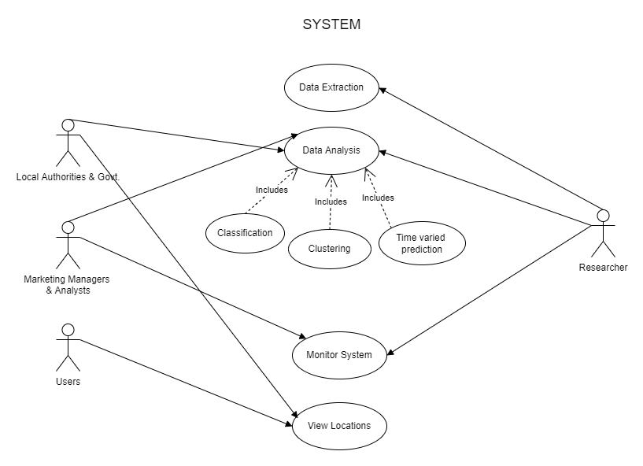

**Theory:**

Actors and their user-scenarios:

* **Users** will have access to the deployed software and can give their choice of value as input to get the desired output.
* **Marketing Managers and Analysts** will check out the accuracy of the analyzed data, will form training and testing sets for models and then use the results for visualizing and drawing conclusions. They will need to be informed about any changes in the data that have occurred.
* **Local Authorities** will be the source for data extraction and accuracy checking.
* **Researchers** will perform multiple tasks.
  + They will research and extract data along with relevant information from various sources like the internet, past surveys and the data given by the local authorities and the government.
  + They will then carry out a detailed analysis on the gathered data using classification tools, clustering algorithms, etc.
  + They will then, along with marketing managers and alaysists, check out the accuracy of the analyzed data, form training and testing sets for models and then use the results for visualizing and drawing conclusions.
  + They will need to be aware about any changes that have occurred in the system and might need to inform the concerned people.
  + They will also deploy and manage the deployed software.

**Class Diagram:**

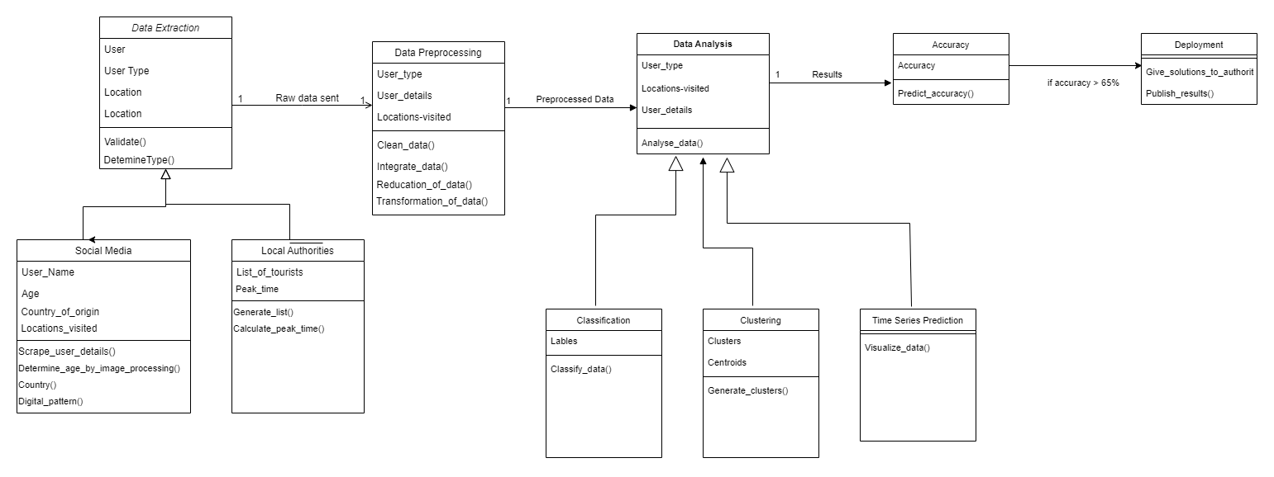

* **Class** - Data Extraction

**Attributes**:

* + User
  + Usertype
  + Location

**Operations**:

* + Validate()
  + DetermineType()
* **Class** - Social Media

**Attributes**:

* + User_name
  + Age
  + Country_of_origin
  + Locations_visited

**Operations**:

* + - Determine_age_by_image_processing()
    - Display_pattern()
* **Class** - Local Authorities

**Attributes**:

* + List_of_tourists
  + Peak_time

**Operations**:

* + Generate_list()
  + Calculate_peak_time()
* **Class** - Data preprocessing

**Attributes**:

* + User_type
  + User_details
  + Locations_visited

**Operations**:

* + Clean_data()
  + Integrate_data()
* **Class** - Data Analysis

**Attributes**:

* + User_type
  + User_details
  + Locations_visited

**Operations**:

* + Analyse_data()
* **Class** - Classification

**Attributes**:

* + Labels

**Operations**:

* + Classify_data()
* **Class** - Clustering

**Attributes**:

* + Clusters
  + Centroids

**Operations**:

* + Generate_clusters
* **Class** - Time Series Prediction

**Operations**:

* + Visualize_data()
* **Class** - Accuracy

**Attributes**:

* + Accuracy

**Operations**:

* + Predict_accuracy()
* **Class** - Deployment

**Operations**:

* + Give_soln_to_authorities
  + Publish_results

**Conclusion**: We learnt about UML Use-Case Diagrams and Class Diagrams and have created them for our tourism analysis project.